**USOC/VOICE-Grade RJ12 Unshielded Keystone Jack**

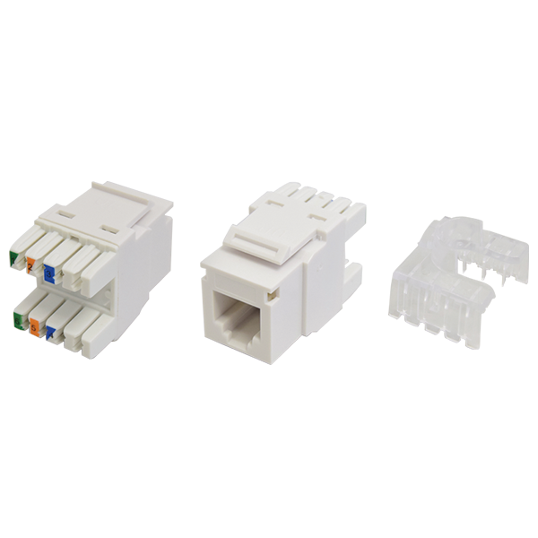

RJ12 Keystone jack is designed for voice-grade cabling.  Products are with Voice/USOC wiring instruction, Keystone snap-in footprint is ideal for all keystone type wall outlet and panels.  IDC is compatible with 110 as well as KRONE punch down tool.

## **Features**

Large selection of colors, provides many options of color coded designation port

USOC wiring

KRONE/110 universal IDC design

**Ordering Information**

|  |  |
| --- | --- |
| **Part No.** | **Description** |
| **0AX6RP000-XX** | RJ12, 8-Conductor Cat.3, KRONE/110 IDC, Unshielded, 180 degree, H.D. version |
| **1KX600000-XX** | RJ12, 6-Conductor Cat.3, KRONE/110 IDC, Unshielded, 90 degree, H.D. version |

***“XX” = Color choices – Ivory (IV), White (WH), Grey (GY), black (BK), Red (RD), Orange (OR), Blue (BL), Green (GN), Yellow (YL)***